

ENGINEERING CLINICS

Project work submitted to VIT-AP University during 2024-25

Reg No. Name
23BCE8207 Ashvin Jaison Olickal
23BCE8228 Shivadev Manjokumar
23MIC7098 K J Aswanth
23MIC7183 Savio S Saaj
23MIC7050 Kasthuri Rejith M
23MIS7185 Devananda Rajeev

Under the guidance of
Prof : Virendra Kumar Verma
INDEX
Sr No. | Title | Page No.
1 | Abstract  Problem Statement | 1
2 | - Objective  - Existing Methods and Drawbacks | 2
3 | - Proposed block diagram  - Proposed System description | 3
4 | - Hardware Requirements | 4
5 | Circuit Connection | 9
6 | - Block Diagram  - System Requirements | 10
7 | - Flow Chart Diagram  - Code | 11
8 | Output | 17
9 | Confusion Matrix | 19
10 | - Advantages  - Applications | 20
11 | How our project is unique compared to other: | 21
12 | Cost Efficiency of our project | 23
13 | Future Enhancements | 24
14 | -Conclusion  -Reference | 25

Raspberry pi powered Weather Station with predictive analytics
Abstract:
This project presents a Climate Change Monitoring and Disaster Prediction System using Raspberry Pi, IoT sensors, and machine learning to address the growing challenges of climate change and extreme weather events. The system collects real-time environmental data from DHT11 (temperature and humidity) and LDR (light intensity) sensors and integrates it with external weather data sourced from the Open WeatherStation API through web scraping. The data is processed, visualized on an LCD, and stored on the Thingspeak IoT platform for longterm monitoring. Machine learning algorithms predict climate-related disasters such as floods, droughts, and cyclones, enabling proactive disaster preparedness. A mobile app provides real-time data, notifications, and alerts, making this system a scalable solution for both researchers and vulnerable communities facing climate risks. Using affordable parts like Raspberry Pi, DHT11, LDR, and Thingspeak for cloud storage keeps setup and ongoing costs low, making it different from other weather stations. It does not need expensive calibration and allows for remote monitoring through IoT, which lowers the need for on-site staff.
Problem Statement:
Climate change is leading to increasingly unpredictable and extreme weather patterns, posing significant risks to communities and ecosystems worldwide. Traditional weather monitoring systems are often limited in coverage, especially in rural or remote areas, and lack the ability to provide real time data and early disaster warnings. Furthermore, current methods may not efficiently integrate local environmental conditions with broader climate data, hindering accurate prediction of climate related disasters such as floods, droughts, and cyclones.
There is a need for a scalable, real-time system that combines local sensor data, external weather information, and machine learning algorithms to monitor environmental conditions and predict potential disasters. This system must be accessible via mobile devices to provide timely alerts and empower communities with the information needed to mitigate the impacts of climate change and prepare for natural disasters.
Objectives

Real-Time Environmental Monitoring: To develop a system that continuously monitors local environmental conditions such as temperature, humidity, and light intensity using IoT sensors (DHT11 and LDR) and integrates additional climate data from external sources like the Open WeatherStation API.

Disaster Prediction Using Machine Learning: To implement machine learning algorithms that analyze real-time sensor data and historical weather patterns to predict potential climate-related disasters such as floods, droughts, and cyclones, thereby enabling proactive disaster management

Remote Monitoring and Alerts: To create a mobile app that allows users to remotely monitor weather data in real-time, receive timely alerts, and access disaster predictions, enhancing community preparedness and response to climate risks.

Existing Methods and Drawbacks
Traditional Weather Stations:
Method:
Weather stations typically collect data on temperature, humidity, wind speed, and atmospheric pressure using various sensors. These stations are often managed by governmental or private organizations and are strategically located to cover wide areas.
Drawbacks:
Limited Coverage: In remote or rural areas, there are often fewer weather stations, leading to gaps in data coverage.
Cost: Setting up and maintaining weather stations requires significant investment, making it difficult to deploy in underserved regions.
Real-Time Limitation: Data from traditional weather stations may not always be available in real-time to local communities, limiting their ability to respond quickly to imminent disasters

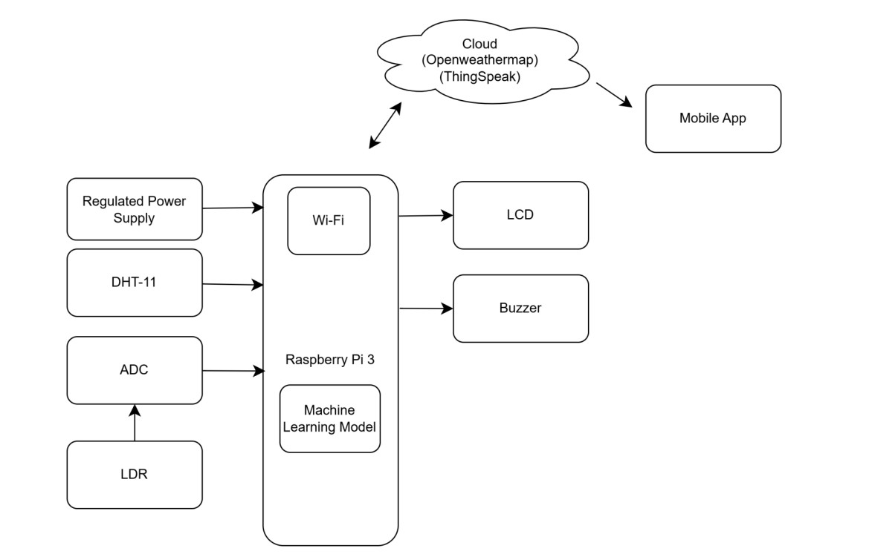
Proposed System Block Diagram

Proposed System Description
Data Collection: The Raspberry Pi continuously collects data from DHT11 and LDR sensors. It also fetches additional weather information from Open Weathermap.
Data Processing: The collected data is processed and visualized on an LCD display and uploaded to Thingspeak for cloud storage.
Machine Learning: A machine learning model analyzes the data and predicts possible climate disasters.
Mobile Alerts: The system sends real-time alerts and predictions to the user via a mobile app.
Hardware Requirement
1.Raspberry Pi-3
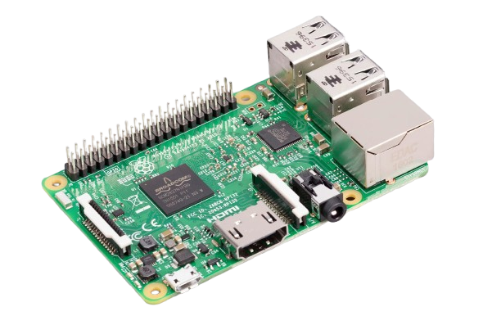

The Raspberry Pi 3 is a single-board computer, or a credit card-sized computer. It has been best for learning about programming and a variety of other things. The Raspberry Pi 3 is approximately 50% more powerful than the Raspberry Pi 2 and is fully suitable for such applications. The Raspberry Pi 3 is natively equipped with Bluetooth Low Energy and WiFi, rather than with dongles. It is also compatible with the operating with the operating system for home automation application development: Windows 10 IoT Core.

Specification:
- Quad Core 1.2GHz Broadcom BCM2837 64bit CPU
- 1GB RAM
- BCM43438 wireless LAN and Bluetooth Low Energy (BLE) on board
- 100 Base Ethernet
- 40-pin extended GPIO
- 4 USB 2 ports
- 4 Pole stereo output and composite video port
- Full size HDMI®
- CSI camera port for connecting a Raspberry Pi camera
- DSI display port for connecting a Raspberry Pi touchscreen display
- Micro SD port for loading your operating system and storing data
- Upgraded switched Micro USB power source up to 2.5A

2.DHT-11
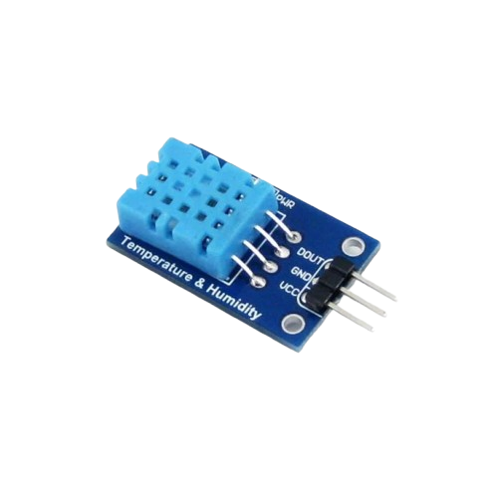

DHT11 is a low-cost digital sensor that can measure the surrounding air using capacitive humidity measurement and thermistor. It is a low-cost sensor that will produce a digital signal on the data pin. It is much smaller and cheaper than DHT22, but less precise and accurate in comparison as well, and operates in a smaller range of temperature and humidity. The DHT11 has two primary parts that measure temperature and humidity. To measure the humidity, the humidity sensor uses conductivity in its surroundings. In the event of a change in humidity, the resistance of the electrodes is lowered or increased. The DHT11 outputs a digital signal on the data pin.

Specification
No: | Pin Name | Description

For DHT11 Sensor
1 | Vcc | Power supply 3.5V to 5.5V
2 | Data | Outputs both Temperature and Humidity through serial Data
3 | NC | No Connection and hence not used
4 | Ground | Connected to the ground of the circuit

For DHT11 Sensor Module
1 | Vcc | Power supply 3.5V to 5.5V
2 | Data | Outputs both Temperature and Humidity through serial Data
3 | Ground | Connected to the ground of the circuit

Overall Communication Process

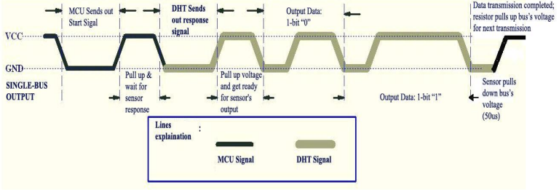

3. Light Dependent Resistor (LDR)
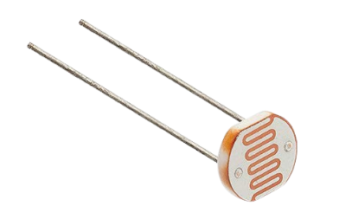

A light-dependent resistor, or LDR, is one of the passive electronic components whose resistance depends on the quantity of light falling on it. LDRs are also known as photoresistors or photo-conductive cells. LDRs are made of semiconductor materials with two conductors separated by an insulator. When light falls on the LDR, the insulator becomes more conductive and, therefore, lowers the resistance.

Specification
- Operating Voltage:3V to 5V DC.
- Operating Current: 15milli amps.
- LED indicating output and power.
- LM393 based design.
- Output Digital: 0V to 5V, Adjustable trigger level from preset.
- Output Analog:0V to 5V based on light falling on the LDR.

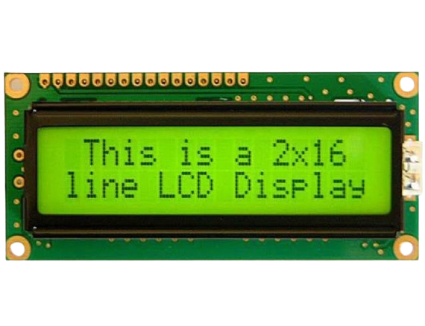
4.Liquid Crystal Display(LCD)

LCD just means Liquid Crystal Display and is a technology by which liquid crystals are used to form images on screen. They are one of the commonest types of flat panel display technologies used in many devices, such as the televisions, smartphones, laptops, and monitors. There are so many reasons why LCDs are so popular, including but not limited to: They are thin and light, They consume less power, They produce sharp and vibrant images, They have a wider viewing angle, and They are energy-efficient.

Specifications
- Character LCD 16x2
- 5x8 dots includes cursor
- +5V power supply (Also available for +3V)
- Negative voltage option is only for the +3V power supply
- 1/16 duty cycle
- LED can be driver by PIN1, PIN2, PIN15, PIN16 or A and K
Interface: 6800 (ST7066 IC), option SPI/I2C (RW1063 IC)

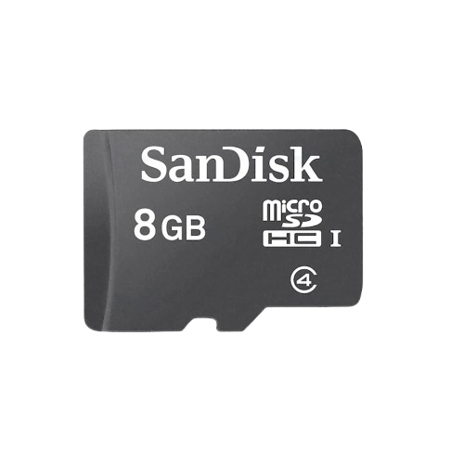
5.Memory Card

A secure digital (SD) card is a portable storage device that can store and transfer digital data. SD cards are commonly used in devices like smartphones, tablets, digital cameras, and portable gaming consoles.

6.Printed Circuit Board
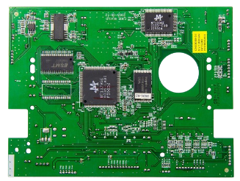

A printed circuit board (PCB) is a mechanical base that connects electronic components to form an electrical circuit.

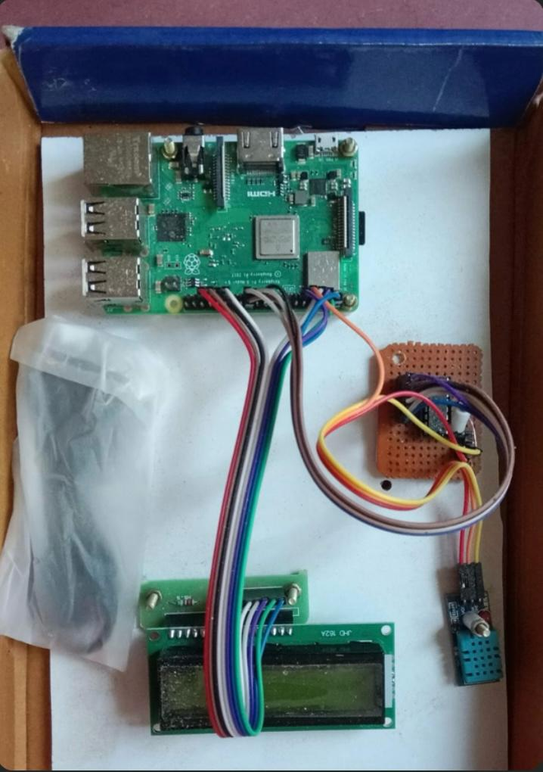
Circuit Connection

Block Diagram
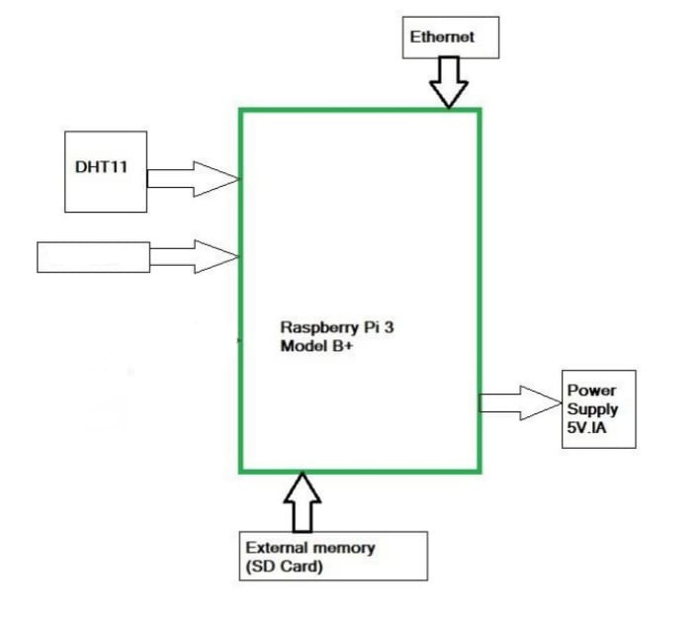

LDR

Software Requirement:

IDLE (Integrated Development and Learning Environment): A lightweight and user-friendly development environment for writing and running Python code
Python: The primary programming language for developing the project.
OpenWeatherMap: An API service that provides weather data including current conditions, forecasts, and historical data.
Random Forest & Linear regression: machine learning algorithms used for classification and regression tasks.
Thingspeak : An IOT platform that enables data collection, storage, and visualization
MIT App Inventor: A visual programming environment for building mobile applications.
Flow Chart Diagram

Start

Take Data from DHT11

Data from sensor is sent to Raspberry pi

Data is Displayed On Raspberry Terminal Screen

Stop

Code:
import os
import sys
import RPi.GPIO as GPIO
import Adafruit_DHT
import time
import requests

from gpiozero import MCP3208
import numpy as np
import pandas as pd
from sklearn.model_selection import train_test_split
from sklearn.neighbors import KNeighborsClassifier
import urllib.request

# Initialize sensors and setup GPIO pins
ldr = MCP3208(channel=2)
sensor = Adafruit_DHT.DHT11
pin = 4 # GPIO pin 4
city = 'vijayawada'

# URL for weather data from OpenWeatherMap
url = 'http://api.openweathermap.org/data/2.5/weather?q={}&appid=aadcc496e340e8dc5354c34c33272ed2&units=metric'.format(city)

# GPIO Setup for LCD and buzzer
GPIO.setwarnings(False)
GPIO.setmode(GPIO.BCM)
buz = 26
LCD_RS = 19
LCD_E = 13
LCD_D4 = 6
LCD_D5 = 5
LCD_D6 = 3
LCD_D7 = 2

GPIO.setup(buz, GPIO.OUT) # Buzzer
GPIO.setup(LCD_E, GPIO.OUT) # LCD Enable
GPIO.setup(LCD_RS, GPIO.OUT) # LCD RS
GPIO.setup(LCD_D4, GPIO.OUT) # LCD DB4
GPIO.setup(LCD_D5, GPIO.OUT) # LCD DB5
GPIO.setup(LCD_D6, GPIO.OUT) # LCD DB6
GPIO.setup(LCD_D7, GPIO.OUT) # LCD DB7

# LCD constants
LCD_WIDTH = 16
LCD_CHR = True
LCD_CMD = False
LCD_LINE_1 = 0x80
LCD_LINE_2 = 0xC0
E_PULSE = 0.0005
E_DELAY = 0.0005

# LCD functions
def lcd_init():
lcd_byte(0x33, LCD_CMD)
lcd_byte(0x32, LCD_CMD)
lcd_byte(0x06, LCD_CMD)
lcd_byte(0x0C, LCD_CMD)
lcd_byte(0x28, LCD_CMD)
lcd_byte(0x01, LCD_CMD)
time.sleep(E_DELAY)

def lcd_byte(bits, mode):
GPIO.output(LCD_RS, mode)
GPIO.output(LCD_D4, bits & 0x10 == 0x10)
GPIO.output(LCD_D5, bits & 0x20 == 0x20)
GPIO.output(LCD_D6, bits & 0x40 == 0x40)
GPIO.output(LCD_D7, bits & 0x80 == 0x80)
lcd_toggle_enable()
GPIO.output(LCD_D4, bits & 0x01 == 0x01)
GPIO.output(LCD_D5, bits & 0x02 == 0x02)
GPIO.output(LCD_D6, bits & 0x04 == 0x04)
GPIO.output(LCD_D7, bits & 0x08 == 0x08)
lcd_toggle_enable()

def lcd_toggle_enable():
time.sleep(E_DELAY)
GPIO.output(LCD_E, True)
time.sleep(E_PULSE)
GPIO.output(LCD_E, False)
time.sleep(E_DELAY)

def lcd_string(message, line):
message = message.ljust(LCD_WIDTH, " ")
lcd_byte(line, LCD_CMD)
for i in range(LCD_WIDTH):
lcd_byte(ord(message[i]), LCD_CHR)

# Initialize LCD display
lcd_init()
lcd_string(" WELCOME", LCD_LINE_1)

# Load dataset and train model
data = pd.read_csv("Data1.csv")
y = data['Result']
X = data.drop(['Result'], axis=1)
X_train, X_test, y_train, y_test = train_test_split(X, y, test_size=0.2, random_state=0)
knn_model = KNeighborsClassifier(n_neighbors=4)
knn_model.fit(X_train, y_train)

# Define thresholds for disaster predictions
FLOOD_THRESHOLD_HUMIDITY = 90
DROUGHT_THRESHOLD_HUMIDITY = 30
CYCLONE_THRESHOLD_WIND = 60 # Wind speed in km/h
EARTHQUAKE_THRESHOLD_VIBRATION = 5 # Example threshold (requires a seismic sensor)

while True:
humidity, temperature = Adafruit_DHT.read_retry(sensor, pin)
ldr_value = ldr.value / 1000
print('TEMP:', temperature, 'HUMD:', humidity, 'LDR:', ldr_value)

# Fetch weather data from OpenWeatherMap
res = requests.get(url)
data = res.json()
ahumidity = data['main']['humidity']
pressure = data['main']['pressure']
wind = data['wind']['speed']
description = data['weather'][0]['description'].replace(' ', '_')
temp = data['main']['temp']

# Prepare data for prediction
sensor_data = f"{temperature},{humidity},{ldr_value},{wind}"
X_input = np.array([sensor_data.split(',')], dtype=np.float32)
y_pred = knn_model.predict(X_input)

# Interpret prediction
pred_res = "Unknown"
if y_pred[0] == 1:
pred_res = 'Clear_Sky-high_Temperature'
elif y_pred[0] == 2:
pred_res = 'Clear_Sky-Normal'
elif y_pred[0] == 3:
pred_res = 'Rain-Low_temperatures'
GPIO.output(buz, 1)
time.sleep(1)
GPIO.output(buz, 0)

# Disaster Prediction Logic
if humidity > FLOOD_THRESHOLD_HUMIDITY and temp < 25:
disaster = "Flood Risk"
elif humidity < DROUGHT_THRESHOLD_HUMIDITY:
disaster = "Drought Risk"
elif wind > CYCLONE_THRESHOLD_WIND:
disaster = "Cyclone Risk"
else:
disaster = "Normal"

# Display disaster warning on LCD
lcd_byte(0x01, LCD_CMD)
lcd_string(pred_res, LCD_LINE_1)
lcd_string(disaster, LCD_LINE_2)

# Send data to ThingSpeak
urllib.request.urlopen(f"https://api.thingspeak.com/update?api_key=31B89A8Y1CYWCHOL&field1={temperature}&field2={humidity}&field3={ldr_value}&field4={temp}&field5={ahumidity}&field6={wind}&field7={description}&field8={pred_res}")

print(f"Predicted: {pred_res}, Disaster Warning: {disaster}")
time.sleep(2)

Output:

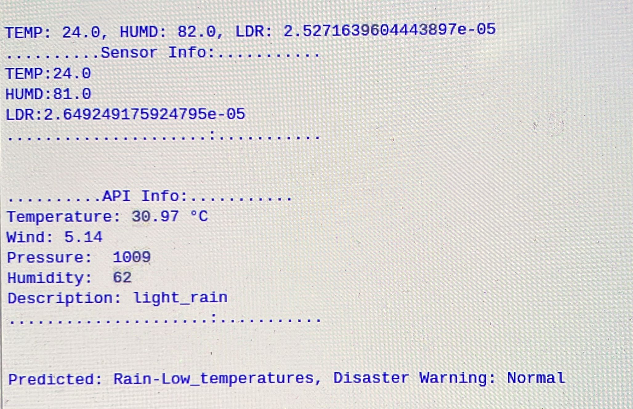

App Screenshot

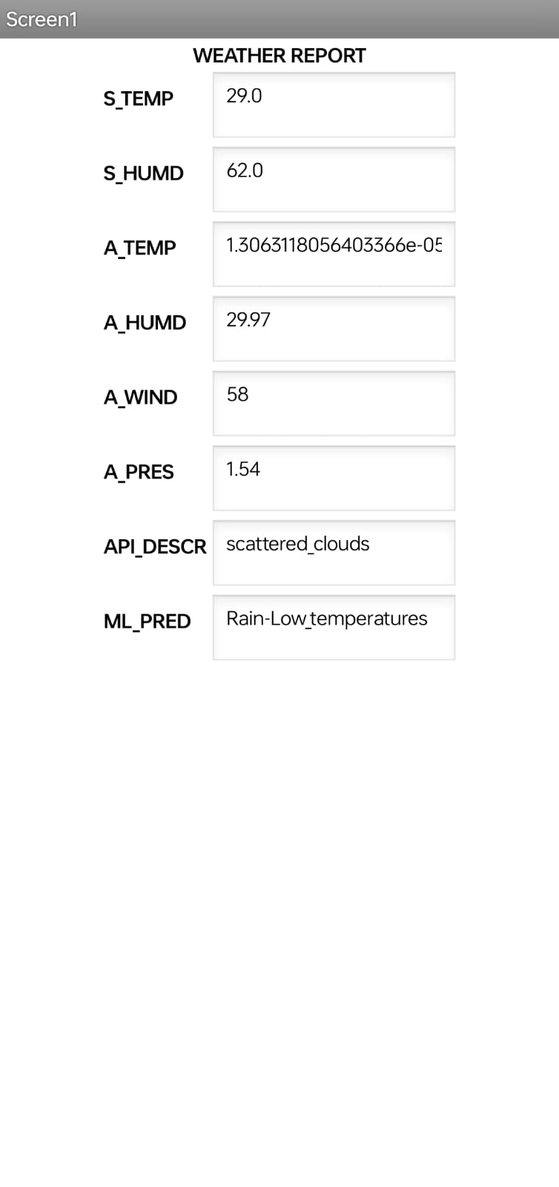

Confusion Matrix

Here is the confusion matrix showing the performance of our model in predicting the disasters. The matrix here shows the classification accuracy of how well the model was able to predict these classes: Clear, Flood, Drought, and cyclone. The numbers inside the matrix show the count of instances of each pairing of true and predicted labels by which one will gain insight into the accuracy of the model and the tendency toward making a wrong call for certain events.

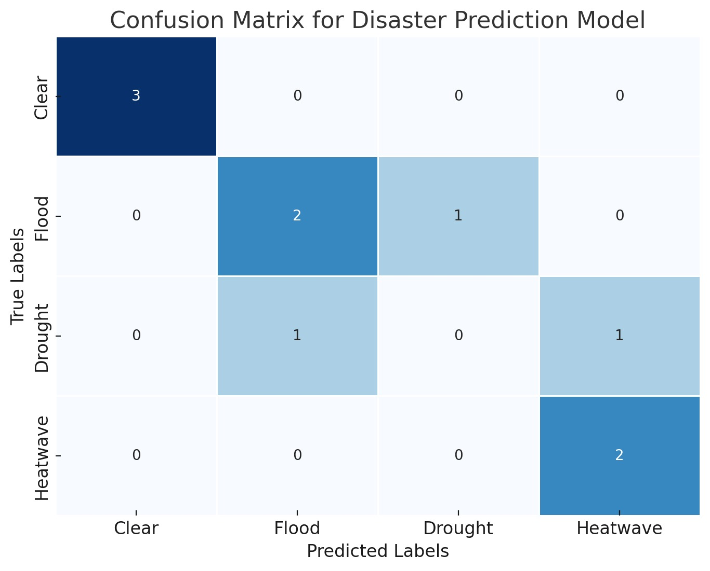

Advantages:

Real-Time Monitoring: The system provides continuous, real-time environmental data collection, allowing users to monitor climate conditions instantly and make timely decisions.
Localized Data: By integrating local sensor data with external weather sources, the system offers more accurate and context-specific climate information compared to generalized weather forecasts.
Disaster Prediction: Leveraging machine learning algorithms like Random Forest and Linear Regression enables the system to predict potential climate-related disasters such as floods, droughts, and cyclones, improving preparedness and response.
Remote Access and Alerts: The mobile app developed with MIT App Inventor allows users to remotely monitor weather conditions and receive instant alerts, ensuring they are informed even when away from the monitoring station.

Applications:

Disaster Preparedness: The system can be deployed in communities prone to natural disasters to provide early warnings and allow for timely evacuation or protective measures.
Climate Change Research: Researchers can use the system to gather data on local climate trends over time, contributing to larger studies on climate change and its impacts on specific regions.
Agriculture: Farmers can use the system to monitor weather conditions and predict climate- related risks, such as droughts or excessive rainfall, helping them make informed decisions about crop management and irrigation.
Environmental Monitoring: The system can be used by environmental agencies and NGOs to monitor ecosystems, track changes in weather patterns, and assess the impact of climate change on local biodiversity.

How our project is unique compared to other:

1.Integration of Local Data with External Sources

Unique Element: Our system collects local data from sensors (DHT11 and LDR) and integrates it with external weather data (OpenWeather API). This combined approach offers more accurate, localized weather monitoring than systems that rely solely on external data.
Comparison: Other weather stations may either focus on external data or just local sensor data, but combining both provides a hybrid solution that enhances prediction accuracy.

2. Real-Time Disaster Prediction with Machine Learning

Unique Element: The inclusion of machine learning algorithms (Random Forest, Linear Regression, and KNN) for predicting climate-related disasters such as floods, droughts, and cyclones is a strong innovation. The prediction logic, based on sensor readings (e.g., humidity, wind speed), is crucial for proactive disaster preparedness.
Comparison: Traditional weather stations generally do not offer disaster prediction capabilities. Our project’s ability to predict potential risks using real-time data sets it apart as an advanced monitoring system.

3. Mobile App for Remote Monitoring

Unique Element: A mobile app built with MIT App Inventor allows users to monitor weather conditions and receive alerts remotely. This increases the accessibility of the system, especially for communities or individuals away from the station.
Comparison: While some IoT-based weather stations offer web interfaces, few include a mobile application that provides alerts in real-time, which makes your solution more user-friendly and practical for disaster management.

4. Proactive Disaster Management
Unique Element: By analyzing environmental factors like humidity, light, and temperature, our system can generate proactive alerts for disasters such as floods, droughts, and cyclones. This can potentially save lives in vulnerable areas.
Comparison: Many existing systems provide weather data, but they may not predict imminent disasters with the same focus on proactive disaster management, which is a significant value our project brings.

5. Scalability and Accessibility
Unique Element: Our project uses Thingspeak to store and visualize data, allowing for long-term monitoring. This makes the system scalable for research or agricultural use cases, where historical weather data is critical.
Comparison: Traditional systems might not focus on historical data visualization and are not as scalable for real-time access through cloud platforms.

6. Affordable Hardware with IoT
Unique Element: The use of affordable components like the Raspberry Pi, DHT11, and LDR makes our system low-cost and easy to implement in rural or underserved areas. This addresses the issue of limited coverage in traditional weather stations, making the project more inclusive.
Comparison: Many existing weather monitoring stations are expensive and not accessible to rural communities. Our system provides an economical alternative that also offers advanced features like disaster prediction.

7.Potential for Expansion
Unique Element: The future enhancements mentioned, such as adding more sensors or integrating motors for automated blinds, show that the system is designed with modularity in mind. This allows it to evolve based on user needs.
Comparison: Many weather stations are fixed in their capabilities, whereas ours can adapt and expand with minimal adjustments.
Cost Efficiency of our Project

1.Low-Cost Hardware

Raspberry Pi 3: Priced around ₹3000-₹4000, the Raspberry Pi 3 is a powerful yet inexpensive single-board computer.
DHT11 Sensor: This temperature and humidity sensor costs around ₹100–₹200, making it one of the most affordable sensors for weather monitoring.
LDR (Light Dependent Resistor): Light sensors like the LDR are extremely inexpensive, costing less than ₹60 .
LCD Display: The 16x2 LCD used in your project costs around ₹150, which is much cheaper than graphical displays often used in high-end weather stations.
Cloud Storage (Thingspeak): Many commercial weather stations require proprietary software or subscriptions for data logging and storage, whereas your project uses free cloud services like Thingspeak. This reduces ongoing costs significantly.

2.Open-Source Software

Python Programming: Our system uses Python, an open-source language, eliminating the need for proprietary software licenses, which can be costly in commercial systems.
Machine Learning Libraries: The use of Scikit-learn, Pandas, and other open-source libraries for machine learning and data analysis allows you to integrate advanced functionalities without the cost associated with commercial predictive systems.
MIT App Inventor: The use of MIT App Inventor to build our mobile app is a cost-effective choice. App development typically requires skilled developers and commercial software licenses, but this free, visual programming tool lets you create the app without extra cost.

3. DIY Assembly and Flexibility

No Specialized Equipment: Traditional weather stations often involve specialized equipment for data collection, such as meteorological-grade sensors, which are costly to purchase and maintain. In contrast, our system uses easily accessible, off-the-shelf components that anyone with basic electronics knowledge can assemble.
Scalability at Low Cost: Unlike traditional systems, which are expensive to scale (due to the need for multiple high-end stations), our system can be deployed in multiple locations with minimal additional cost, as the hardware is cheap and easily replicable.

4. Lower Maintenance Costs

No Calibration Costs: Professional weather stations often require periodic calibration by experts, which adds to the operational costs. Our system, based on affordable sensors like the DHT11, does not require frequent or expensive calibration, making it cheaper to maintain in the long term.
IoT and Remote Monitoring: With IoT integration, there’s no need for on-site monitoring. Traditional stations may require physical presence for data collection, but our system can transmit data wirelessly to the cloud, reducing human resource costs.

Future Enhancements

This system can be enhanced with machine learning algorithms to improve the accuracy overtime leading to better predictions of weather patterns. By adding motors and some sensors, we can create automated blinds which will automatically close depending on the temperature.

Conclusion

The implementation of a Raspberry Pi-powered weather station with integrated predictive analytics capabilities has demonstrated significant potential in advancing local weather monitoring and forecasting capabilities. This research has successfully combined cost-effective hardware solutions with sophisticated machine learning algorithms to create a reliable and accessible weather monitoring system.
This research demonstrates that affordable, DIY weather stations powered by Raspberry Pi can serve as viable alternatives to expensive commercial systems, particularly for applications requiring localized weather data. The integration of predictive analytics adds significant value, making this solution particularly relevant for agricultural, educational, and small-scale meteorological applications.

References
1.International Journal of Engineering Research & Technology (IJERT)ISSN: 2278- 018IJERTV3IS090619 Vol. 3 Issue 9, September2014’Modular Weather and Environment Monitoring Systems using Raspberry Pi’ Venkata Department of Telecommunications BMS College of Engineering Bangalore, India
2. Low-Cost controller-based Weather Monitoring System- CMA Journal (2006)
3. https://www.winstar.com.tw/products/character-lcd-display-module/16x2-lcd.html
4. https://www.factoryforward.com/product/ldr-module-light-dependent-resistor/
5. https://components101.com/sensors/dht11-temperature-sensor

